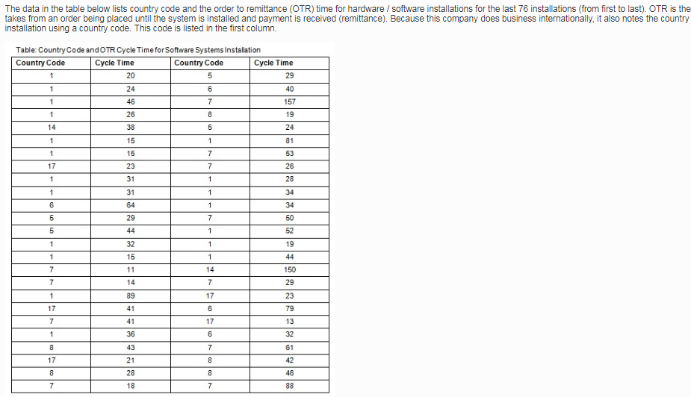

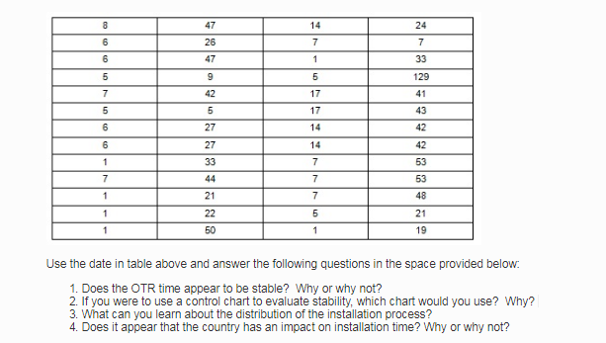

QUESTIONS:
1). Determining the Stability of the OTR Time
SOLUTION: No, the provision of the OTR Time is less stable because of a negative skewedness, which makes the provision of installation time asymmetrical. The data set above had a positive skewedness of 11.85. A data set with a positive skewedness indicates a right tail that is longer and significant distribution aligns to the left.
Computing the skewedness:
i). clustering the data set into set of distinctive classes
Table 1: Group Frequency Distribution
Class-limit | Cycle time  Classes | Frequency  (f) | Cumulative frequency | Midi-point  (x) | f₁x₁ | f₁ (_{x1})²
4.5-26.5 | 5-26 | 26 | 26 | 15.5 | 403 | 6,247
26.5-49.5 | 27-49 | 34 | 60 | 38 | 1292 | 49,096
49.5-72.5 | 50-72 | 8 | 68 | 61 | 488 | 29,768
72.5-95.5 | 73-95 | 4 | 72 | 84 | 336 | 28,224
95.5-118.5 | 96-118 | 1 | 73 | 107 | 107 | 11,449
118.5-141.5 | 119-141 | 1 | 74 | 130 | 130 | 16,900
141.5-164.5 | 142-167 | 2 | 76 | 153 | 306 | 46,818
∑ |  | 76 |  |  | 3,062 | 188,502

ii). Calculate the mean of the grouped data
$$\sum_{i=1}^{n}{f1x1}÷n$$
Therefore, using equation above to determine the mean of the cycle time distribution to be ẍ=40.29
iii). Consider the median of the grouped data
$$LO+\left(\frac{n}{2}-C.F÷f\right)i^{c}$$
Where, L_{o} =lower class limit of the median class
N= the size of the data set
c.f= cumulative frequency of all classes preceding the median class
f=class frequency of the median
$i^{c}$= class interval of the median class
Substituting the median formula for grouped data with the highlighted class
72.5+ [(36-68) ÷ 4]*22
72.5 +7.5*22
72.5+165
Therefore, the highlight set of data gives a Median value 237.5
iii). Compute the standard deviation for the data
---Variance (S²) = {$\sum{f1x1∩}2-\sum{[f1x1/n]∩2}$ } n-1
S² ⁼ {188502- [3062/76]²} ÷ 75
S² = 2491.91
S² = $√$2491.91
Therefore, the standard deviation for the data set is the square root of the variance, which is 49.91
iv). having determined the Median, Mean, and the standard deviation, it is essential to compute the skewedness of the data set using the formula
S.K= 3(Mean-Median) ÷ standard deviation
Skewedness = 3(40.29 – 237.5) ÷ 49.91
11.85
Question 2: Effective Control Chart
The choice of a statistical control chart depends on the symmetrical or asymmetrical nature of the set of the data. In the case above, the asymmetrical nature of the data requires the utilization of a Variable Control Chart, which reveals the mean and lower class-limit in the data. Therefore, Mean and Histogram-Chart is suited because it traces the process standard deviation and computes the range-distribution within the data.
Further, a histogram merits because it shape the trend in provision of the cycle among the 76 clients. A histogram is a mirror that reflects on the extent of skewedness in the allocation of cycle times. Therefore, when both the left side and the right side of the histogram are a similar, it indicates the existence of symmetry. However, the histogram below indicates asymmetry in the data because of the right-skewedness in the allocation of the cycle time. The figure below imply that significant amount of OTR cycle time is more in the lower classes. The company can remedy the trend by focusing on the middle and upper classes using the exponential frequency curve.
Figure 1: Histogram Chart

Question 3: Lessons about the Distribution of Installation Process
The first lesson regard to the asymmetrical pattern in distribution of the installation process. The histogram diagram above reveals that installation process with high cycle times is less favorable because the class cluster beyond 73-95 OTR had the least frequency. For instance, the company can effectively manage its customer because 78.9% of the installation process involves cycle times with a range of 5 and 49 Cycle Times.
Question 4: Effect of a Country toward the Installation Time
The country of a client has no influence on the installation time because of the asymmetrical distribution nature in the installation time, which is evident in the histogram chart above. For example, the country code 1 is the mode of the countries served by the company and has a mean-score of 34-installation time. The country code 5 has a mean installation time of 44-OTR. Comparatively, the countries with the extreme codes are 14 and 17 reveal a mixed outcome in the distribution time. The country code 14 has the highest installation time of 59-OTR. On the contrary, the country code 17, which is the extreme country, had indicated the least mean-installation time of 32 OTR. Therefore, the mixed outcomes in the sample of four countries imply the company fails to consider the influence of a country during the distribution of the installation time.
Table 2: Reveal Distribution of Installation-time across the Countries
Country code | (Mean) Installation Time
001 | 34
005 | 44
014 | 32
017 | 59

